**Types of Stepper Motor**

By construction the step motors come into three broad classes:

1.      Permanent Magnet Stepper

2.      Variable Reluctance Stepper

3.      Hybrid Step Motor

**1.    Permanent Magnet Stepper :**

* 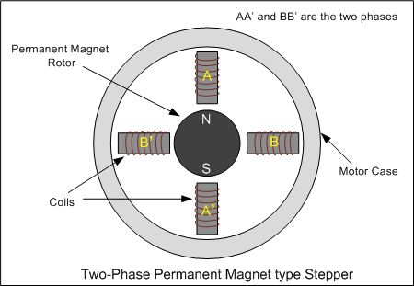The rotor and stator poles of a permanent magnet stepper are not teethed. Instead the rotor have alternative north and south poles parallel to the axis of the rotor shaft.
* When a stator is energized, it develops electromagnetic poles. The magnetic rotor aligns along the magnetic field of the stator. The other stator is then energized in the sequence so that the rotor moves and aligns itself to the new magnetic field.
* 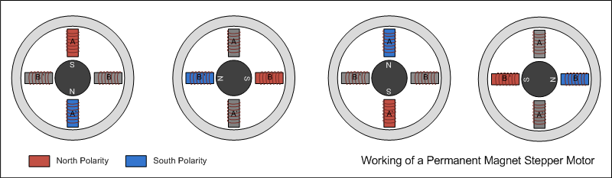 This way energizing the stators in a fixed sequence rotates the stepper motor by fixed angles.

The resolution of a permanent magnet stepper can be increased by increasing number of poles in the rotor or increasing the number of phases.

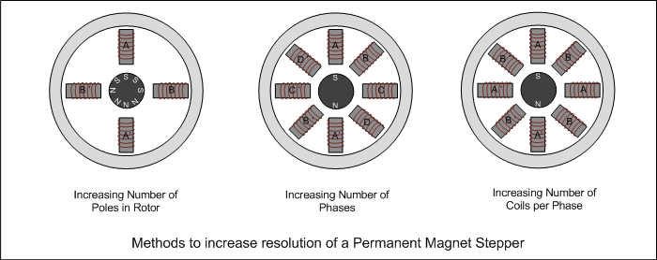

**2.    Variable reluctance stepper :**

* 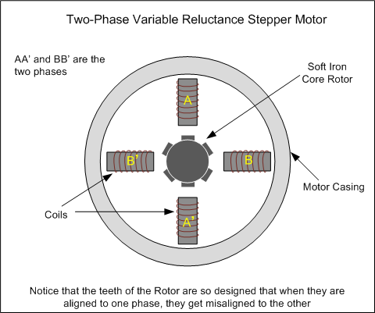The variable reluctance stepper has a toothed non-magnetic soft iron rotor. When the stator coil is energized the rotor moves to have a minimum gap between the stator and its teeth.

* The teeth of the rotor are designed so that when they are aligned with one stator they get misaligned with the next stator. Now when the next stator is energized, the rotor moves to align its teeth with the next stator. This way energizing stators in a fixed sequence completes the rotation of the step motor.

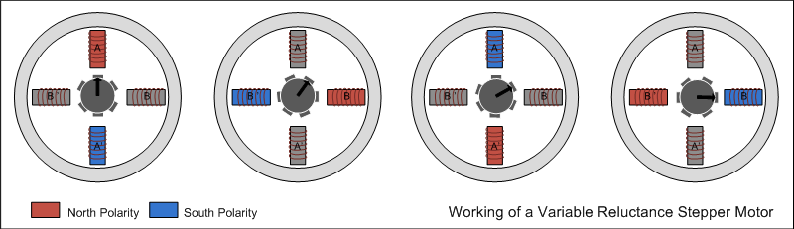

* The resolution of a variable reluctance stepper can be increased by increasing the number of teeth in the rotor and by increasing the number of phases.

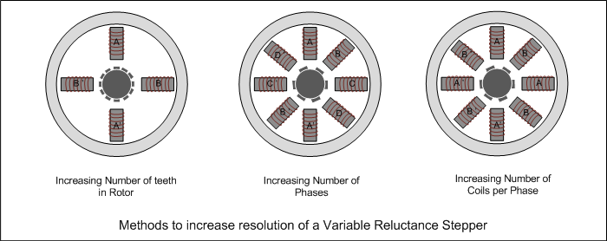

**3.    Hybrid stepper : (the motor which you are working on is a Hybrid stepper motor)**

* A hybrid stepper is a combination of both permanent magnet and the variable reluctance.
* Hybrid rotors are axially magnetized, one end polarized north and the other polarized south.
* Both the rotor and the stator assemblies of hybrid motors have tooth-like projections.

The Hybrid motor rotates on same principle of energizing the stator coils in a sequence.

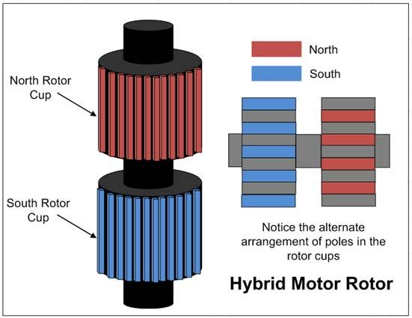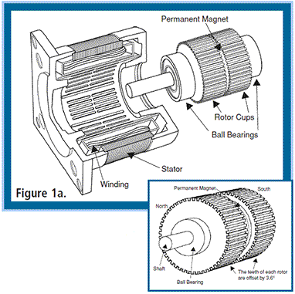

Figure 1a depicts a 1.8° hybrid step motor.

* The rotor is composed of two 50-tooth rotor cups enclosing a permanent magnet. The two cups are oriented so that the teeth of the top cup are offset to the teeth of the bottom cup by 3.6°.
* The stator has a two-phase construction. The winding coils, 90° apart from one another, make up each phase. Each phase is wound so that the poles 180° apart are the same polarity, while the poles 90° apart are the opposite polarity. When the current in a phase is reversed, so is the polarity, meaning that any winding coil can be either a north pole or a south pole.
* 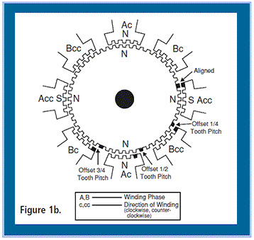. As shown in fig. 1b below, when phase A is energized, the windings at 12 o’clock and 6 o’clock are north poles and the windings at 3 o’clock and 9 o’clock are south poles. The windings at 12 and 6 would attract the teeth of the magnetically south end of the rotor, and windings at 3 and 9 would attract the teeth of the magnetically north end of the rotor. ***The desired direction of travel determines the next set of poles to be energized***

If we need a clock wise rotation, this is the sequence in which we have to energize the coils (refer figure 1b)

1. Energize coil A
2. Energize coil B
3. Energize coil A with reverse polarity
4. Energize coil B with reverse polarity

Every time we energize one coil the rotor rotates by ***1.8°(in this case).***

This sequence should be repeated to complete a rotation i.e 360°

Similarly the reverse has to be followed for anti-clock wise rotation.

* The driver controls this phase sequencing. Because there are 50 teeth on the rotor, the pitch between teeth is 7.2°. As the motor moves, some rotor teeth are in alignment with the stator teeth. The other rotor teeth are out of alignment with the stator teeth by 3/4, 1/2 or 1/4 of a tooth pitch.
* When the motor takes a step, it will move to the next closest position where the rotor and stator teeth are aligned. The rotor will move 1/4 of 7.2°. The motor will move 1.8° with each step.

References: